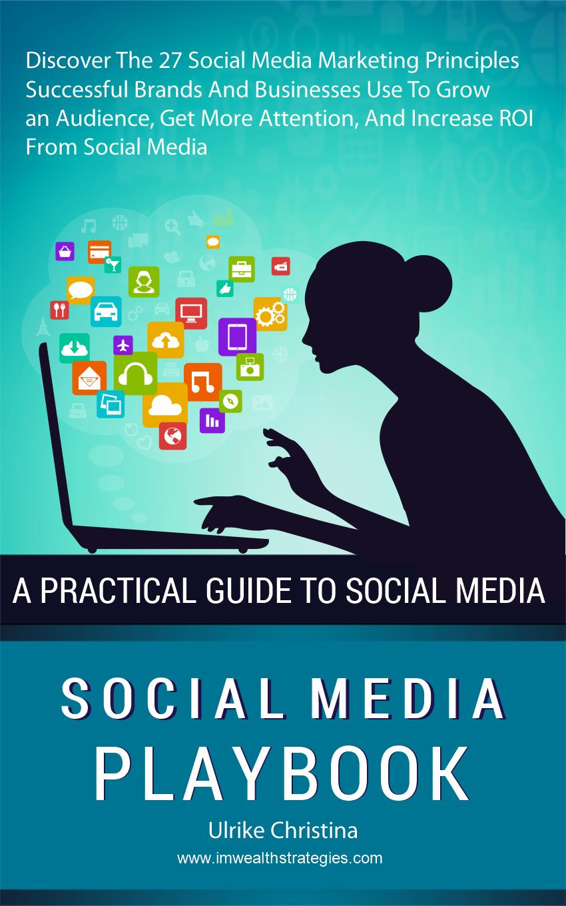

THE SOCIAL MEDIA PLAYBOOK

Discover The 27 Social Media Marketing Principles
Successful Brands And Businesses Use To Grow an Audience,
Get More Attention, And Increase ROI From Social Media

Author: Ulrike Christina

Copyright @2017, Ulrike Christina

All Rights Reserved

www.imwealthstrategies.com

Why you should read this book:

If you want to be one of the major players in your chosen niche, then you need to know exactly how to build an audience, gain their loyalty and keep them coming back to your site time and time again.

But there’s not just ‘one secret’ to this. In fact, there are countless little things that the very best do differently. These are the things that set apart those incredible brands and make them the huge household names they are today. Things like Bodybuilding.com, The Verge, Mashable, Tim Ferriss, Smart Passive Income, Engadget, Wired…

While these companies also have the advantage of having built up their name over countless years and huge amounts of investment to pour into their marketing and sales, it’s still really the strategy that is the big difference.
And this book is going to share that strategy and some of the most powerful tips that set the very best apart from the less special. Now, let’s cover the best and newest Social Media strategies for your Marketing Success.

Table of Contents

Introduction 8
Provide Value 10
Don’t Just Promote 12
Post What YOU Would Want to Read 11
Learn How to Create Titles That Grab Attention 13
Understanding the ‘Value Proposition’ 14
Always Deliver on Your Promise 16
Make Your Followers Feel Important 19
What’s in a Brand? 21
Give Back to the Community 23
Be Personal (Where Appropriate) 26
Promote Your Social Media on Your Blog 28
Learn to Sell the Lifestyle 30
Respond and Engage 32
Be Consistent 34
For More Difficult Niches 35
Experiment With Other Types of Content 38
Be Everywhere 40
Case Study: Arnie on Snapchat 41
Take Advantage of New Technologies 43
Create a Professional Brand 45
Logo Design Tips 46
Go Cross-Niche 48
Don’t Try to Cater to Everyone 49
Use Advertising 51
Work With Partners and Influencers 53
Use Contests and Other Events 55
Offer Discounts 56
Understand the Psychology of Sharing 58
Make Great Quality Posts 60
Learn to Take Amazing Photos 61
Automate 63
Cultivate True Fans 64
Conclusion 65

Introduction

What does it take to become one of the top respected brands on the web, in any niche?
It takes a LOT of hard work and grit – that’s for sure. But it also takes a lot more than that. It takes strategy, cunning and actually a big helping of luck!
If you want to be one of the major players in your chosen niche, then you need to know exactly how to build an audience, gain their loyalty and keep them coming back to your site time and time again.
But there’s not just ‘one secret’ to this. In fact, there are countless little things that the very best do differently. These are the things that set apart those incredible brands and make them the huge household names they are today. Things like Bodybuilding.com, The Verge, Mashable, Tim Ferriss, Smart Passive Income, Engadget, Wired…
While these companies also have the advantage of having built up their name over countless years and huge amounts of investment to pour into

their marketing and sales, it’s still really the strategy that is the big difference.
And this book is going to share that strategy and some of the most powerful tips that set the very best apart from the less special…You will learn…
- How to make the most of your online brand
- How to leverage the power of social media to gain shares, likes and followers
- How to integrate your social media with your website for better
synergy
- The most important platforms you need to be on
- How to make your brand professional
- How to grab attention with great headlines
- How to deliver true value
- How to avoid losing followers
- How to become part of a community
- How to work with influencers And much, much more…

Provide Value

Here is the single most important thing you must know about thriving on social media: it is absolutely imperative that you always provide value.
What does this mean? It means that you’re going to be offering something concrete and tangible to your audience and giving them something that they can benefit from. Think of your social media much like a product or a service in its own right and NOT just a means to get as many people to your blog as possible.
This simple paradigm shift is the absolute difference between a successful social media channel and an unsuccessful one. You need to give people a reason to follow you, a reason to share your content and a reason to keep checking back to your page. Don’t just expect people to follow you on Twitter because they ‘like your brand’!
So how does one go about providing value? In the case of social media, this can mean offering:
- Entertainment
- Information

- Discounts and offers
- Inspiration
A good example of this is any of the thousands of successful channels on Instagram that post pictures of healthy lifestyles. There are a lot of great Instagram accounts run by fitness experts and enthusiasts and that include images of people working hard in the gym, looking great topless on the beach or downing protein shakes. People find this inspiring in helping them move toward their goals and so if the images are well composed and they are well designed, then they are providing value in that way. People know that by following that account, they’ll get updated regularly with new inspiring pictures to help drive them further in their own training.
Another example might be to share links to informative posts on a Facebook account. If you have a blog about online business, then you can post links to news stories regarding SEO, to tips and ideas for creating content etc. Don’t only post your own content – find and share the kind of exciting content that your audience can benefit from! (Note that this is all much easier if you genuinely are passionate about the subject matter – as that way you can simply share the things you’re reading anyway!
But perhaps the best example of ‘social media as product’ would be one of the many Pinterest boards on Pinterest. These tend to act as collections of ideas for interior design, for weddings, for personal style etc. Thus, many people will head to these pages whenever they need ideas and some brands that have come up with related boards have been able to garner huge followings that way.
How do you know if you’re doing this right? Ask yourself this simple question: if your social media channel were to shut down today would your followers be disappointed? We’re not asking if they would notice – we’re asking if they would genuinely feel that something they enjoyed had gone.
If the answer is yes, then congratulations! You are officially providing value.

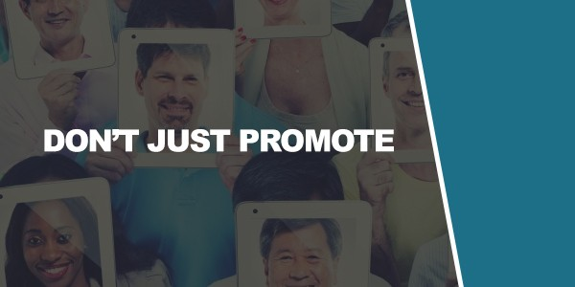
Don’t Just Promote

That’s what you need to do then but just as important is what you need to
avoid doing.
What is the polar opposite of providing value?
The answer is simply promoting your business. And this is what too many misguided small businesses actually use their social media to do. These tend to be the kinds of companies that feel a little stuffy and out of touch to the user. Local service businesses like plumbers and removal men, or more corporate operations like EPOS providers and time clock solutions/accountants.
These are the companies that will use their social media to post things like ‘Visit our site and see why we’re the best at what we do!’. Or, ‘Our software solutions are second to none!’.
This is literally just advertising and it completely misses the point of social media.
Don’t do it!

Post What YOU Would Want to Read

So why is self-promoting wrong?
The answer is that it’s not offering any value. People do not want to go out of their way to be advertised to and they don’t want adverts showing up in their home feeds alongside posts from their friends and family! This will simply demonstrate a lack of understanding on your part (hurting your reputation) and it will frustrate your visitors likely motivating them to simply unsubscribe and leave.
And can you imagine anyone actually clicking on a post about why you’re the best accounting company in the [INSERT AREA] region? No, didn’t think so…
The best way to get a good idea of whether your posts are ticking the right boxes is simply to ask yourself: would you read it?
If this came up on your homefeed, how would you feel? If you’d be pleased and then go on to read it and possibly share it, then it’s an ideal choice for your own social media channel!

But if you’d ignore it, or worse yet feel frustrated, then that’s a sign you shouldn’t do the same.
Look at your own history on these sites and ask yourself why you clicked on the links you did and shared the things you did. What are the best posts you’ve seen in your niche lately? Why? What can you do to emulate their success?
The key here is to remember that your audience are real people who have the agency to follow whatever they want and leave when they want. Thus, you need to get inside their heads.
Often that just means putting yourself in their shoes but another option is to create your fictional ‘persona’. A persona is a buyer biography – an imaginary individual that you will consider to be your ideal customer. By getting inside their heads, you can know precisely what kind of content you should be creating/sharing and you can speak directly to that person with things that will interest them.
One way to do this is to think of someone in your own life who would be your ideal customer. I sell fitness products for instance and I have a few friends who always want to get into shape and are always asking for advice but who never put the time in to get the results they need. They are the ideal customer for a fitness ebook or a protein shake and so I keep them in mind whenever I create content for my social media pages – I write to them and write in a way that will get them interested and engaged!

Learn How to Create Titles That Grab Attention

Writing content and sharing posts that can do this is the crucial skill you need to develop if you’re going to build and grow your social media channels.
But there is nowhere where this is more important than in the titles of your posts. Your title is your first impression – it’s like wearing the right suit to an interview.
In this case, if you want people to read your content, then you need to make sure you are creating really great titles that will really stand out and sound fascinating, unique and exciting.
We can see this when we look at clickbait and that’s the reason that clickbait has become some popular.
In case you’ve been living under a rock, a clickbait title is a title that is designed to grab attention and encourage clicks. Often, it does this by piquing the interest of the reader with some kind of mystery or shocking

statement. In other cases, the language might even be intentionally strange, such that people will be interested to click it and find out what’s going on.
Here are some examples:
“Fitness Trainers Hate Him! Find Out How This Man Has Been Overturning Centuries of Fitness Advice”
Or
“Try This One Weird Trick to Get Rid of Bodyfat!”
Or
“This Man Told Me His Secret to Making Money Online… What Happened Next Will Shock You”
Or
“10 Tricks to Look Sexier Instantly. Number Four Changed My Life!”
In each case, there is some mystery. Who is this man who fitness trainers hate? What’s so special about number four? What’s the ‘weird trick’?
These titles invite clicks because they sound and look interesting and readers can’t help but want to know more. What’s more, is that the titles all allude to the fact that the information can somehow change their lives or at least be shocking and controversial. In either case, this information doesn’t sound boring – it sounds engaging and enticing and it’s very hard to keep on scrolling past. Especially if you combine it with an image of someone looking very attractive, or before and after pictures showing an incredible body transformation!

Understanding the ‘Value Proposition’

Something to understand as you’re doing all this is what your value proposition is.

Your value proposition should go beyond just your social media. This is rather the entire ethos behind your brand and it should be the reason your business exists: your ‘why’.
So what does all that mean? Essentially, it means that you should be aiming to sell more than just a product or a service, you should be selling a dream, an idea or something that can one way or another, improve people’s lives.
The old saying goes that you ‘don’t sell hats, you sell warm heads’. What this means, is that what you sell is more than the sum of its parts. What you sell is the result and the way that result makes you feel. And this is what will provide the emotion behind your products – the emotion that drives people to want to buy from you.
If we were going to apply this to selling something like a fitness ebook, then your ‘value proposition’ would be the feeling of being healthy, sexy and strong. Get your viewers to imagine what it would be like to have a six pack, to have muscles and to have the confidence and energy levels that come with that.
Likewise, if you’re selling a make money program, then your value proposition should come from what it would be like to have lots of cash, no money problems and the ability to travel and buy nice clothes. It would be the attention that would get you from the opposite sex too.
When you can tap into the ‘value proposition’ of your business, then you can find an emotional hook for your posts that will be relevant and that will make people actually stand up and take notice.

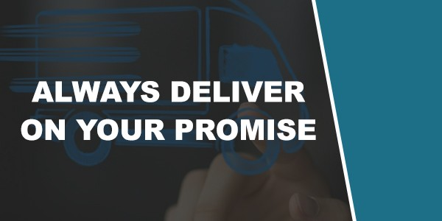
Always Deliver on Your Promise

Wait a minute…!
Did I just recommend that you use clickbait? Isn’t clickbait essentially spam?
Why yes it is. I’m glad you picking up on that and I’m glad that you see the problem here. I am not recommending that you start posting clickbait articles.
All I’m saying is that you can learn from clickbait articles. These stand out because they have interesting concepts that speak to us on an emotional level and get us to want to click.
The problem? They never deliver on their promise. And they’ve reached the point of becoming transparent and contrived.
Very often, you’ll read about this ‘one weird trick’ or the supplement that ‘should be banned’ and it will be nothing but an advert for something very generic. Or you’ll watch a long video to see ‘what happens next’ and you’ll be disappointed to find that nothing much happens.

Often you’ll need to click through lots of sliders filled with large amounts of adverts.
And as such, you’ll learn NOT to click on clickbait because it never delivers. So it’s a catch 22. What is an internet marketer to do?
The answer is to take what works about these posts and avoid what makes them suck…
To explain, let’s take a step backward again and look at what’s wrong with a LOT of internet content. And that’s that it doesn’t stand out in anyway or offer anything unique.
In the fitness niche, there are hundreds of posts for example with titles like: “The Top Ten Home Ab Exercises”
Or
“How to Get Cut Abs”
How many times have you read articles with these titles, or titles similar to these? The answer is most likely very often. And once you recognize that, you can see where the problem lies.
Go back to what we said earlier: would you click it?
Would you click an internet marketing post called: “5 SEO Tips”? Probably not… it couldn’t be more boring sounding!
Clickbait really stands out on social media channels that are filled with this kind of stuff because they actually sound interesting and they actually look unique. Hearing about the ‘weird secret trick’ is much more inviting than hearing about ‘5 ab exercises’.
The problem is that this technique is spammy. So what do you do?

The answer is simple: you go out and you hunt down exciting information to share that is worthy of such a bombastic title. That’s right: you stop trying to ‘trick’ your followers and instead give them exactly the exciting and unique kind of expose that they’re looking for.
There are countless cutting edge studies sharing new forms of training that might have incredible results. There are ancient and forgotten training methods. And then there are those much more interesting angles on the same old topics: things like looking at how fitness relates to self-defense.
Or perhaps how building muscle will change your psychology.
All this is now sounding MUCH more interesting and engaging and you can create post titles that are just as eye-grabbing and exciting.
But the big difference is that now you are going to be able to deliver something really meaty and interesting when your audience follows through by clicking those links. And because you’ve done that, it means that the next time they see one of your posts, they will be inclined to believe that you’re once again going to be able to deliver on your promise. When you combine these methods, the result is that you can gain a loyal following of people who are truly excited and eager to see what your next post will be about!
And when you share content that other people have created, you need to be just as selective and make sure that it ticks all those same boxes: sounds amazing, delivers on its promise.

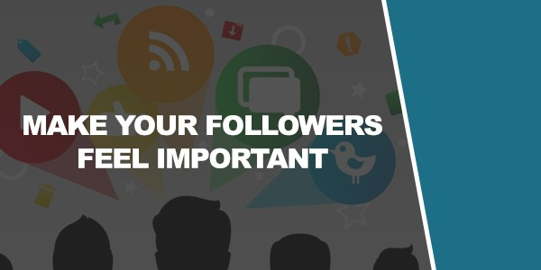
Make Your Followers Feel Important

If you do all this then your social media channel will instantly be better than a huge proportion of what’s out there at the moment. But it won’t be perfect.
Why?
Because if you look at social media only from that perspective then you’re missing out on a very big part of it. Simply put, social media is a social tool. It’s intended for communication and that’s a two-way thing.
Even if you’re posting the very best content in the world, if that’s all you’re doing then it will still feel like a one-way bombardment that will quickly become frustrating for your following.
So instead, you need to focus on that social aspect too by actually engaging with your audience and communicating with them rather than making this a one way thing.
And this starts by treating your visitors like VIPs.
This is a small and simple difference but it’s one that can have a huge impact on your success.

The key is to make following you on social media seem like an exciting lifestyle change and the first step on a great journey.
If your social media channel is about fitness for example, then you can create a situation where simply signing up to your social media channel feels like the first step toward the body your audience wants.
Did you know that people who tell others about their plans to get into shape often fail to do so? The reason for this is that simply telling other people that you plan to lose weight or build muscle relieves some of the psychological tension of wanting to achieve a goal. When we tell people, it becomes a part of our identity and that means we sometimes feel as though we don’t have to work so hard!
Of course this is not a good thing but what it does show, is how making a social step like this can actually feel like positive progress and even bring a sense of catharsis and achievement. When someone clicks on your ‘follow’ button, you can make them feel like they’ve taken the first step to a new them: more confidence, more muscle, more money, more sex… And that makes them feel great about themselves, which is excellent feedback!
Your job is to encourage this feeling by positioning your social media channel as some kind of movement, some kind of statement. This is why many of the most successful online brands will tell people to ‘Follow and take part in the new fitness revolution!’ or ‘Join a community of elite money makers!’.
This also has another advantage, because it makes your followers feel like they’re a part of a community. This creates social pressure to join (everyone who is anyone is following you!) and it makes them feel that they may be missing out by not following. People hate missing out but they love being a part of something and if you can combine these two feelings, then you will be on to a winner!
You can then also carry this on by making your followers feel like VIPs in the way you continue to speak to them throughout. For example, you might refer to them using a group name, or you might tell them how they are

receiving early access, or restricted information. Anything that makes them feel good and feel excited to be a part of your brand.

What’s in a Brand?

A big part of this will come automatically from building your brand in the right way to begin with. A brand is much more than simply a logo you see. Rather, a brand is all about your value proposition (as we’ve discussed) and your ‘why’.
Going back to that why, we can refer to Simon Sinek’s ‘Golden Circle’. This is the idea that you need to understand three ‘rings’ of your business. The outer ring is ‘What’, which is the service or product you create. Ring two is ‘How’ which is how you make it different and how you achieve it at all. And the inner circle is ‘Why’. Why do you do what you do? What is it that you want your business to achieve? How do you want to make your mark on the world?
And it’s by emphasizing this why over the what that you can create a brand that people are excited to get behind.
We’ve already seen that the best way to market your social media channel is to create real value. But it also follows that you need to be able to have a motivating force and a vision behind your products themselves.
Look at Apple. Apple didn’t create a computer and then try to find a purpose for it. Jobs and Wozniak began with their why. Their reason for existing was to make computers fun, personal and creative. They wanted to overturn the idea that computers were for businesses only and they wanted to empower people to be creative and expressive.
That is what enabled Apple to thrive. That is why people responded to their products. That is why there are still so many fervent Apple fans today – despite the hardware being technically inferior and no longer quite so ground breaking.

Other companies aim to give people more personal freedom. Or they aim to make the planet a cleaner place to live. Or they aim to help us see the world. Or achieve financial independence.
What is it that makes you wake up in the morning? How is it that led to your business?
Focus on that because that is a movement and a vision and that is massively more motivating, engaging and exciting than ‘We Sell Washing Machines’.
Plus, once you find the reason for your brand’s existence, then you can start to look into other ways of expressing that so that you can find ways to deliver value through your social media channels or to generally be more inventing and creative with your marketing etc.

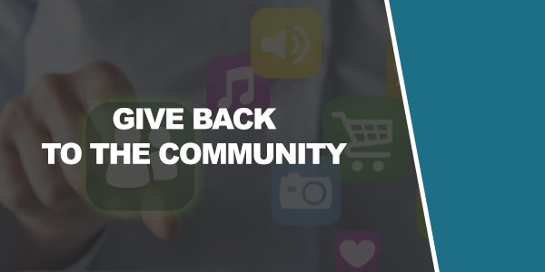
Give Back to the Community

As you’re hopefully starting learn, being a ‘good business’ is good for business. Putting your viewers first, delivering value and not just spamming… these all lead to real engagement and following. It can take a little longer but in time, it’s a much better strategy that will yield far greater results.
And another example of this is just how beneficial it is to give back to the community. And by that, I don’t mean doing community service and washing graffiti off of the walls! (Although that would likely be good for PR…)
Instead, I’m talking about giving back to the community in your niche by actively taking part in posts and discussions that have no bearing on your brand and nothing to do with self-promotion. With no ulterior motive at all, comment on the posts others share, answer questions and generally help out in the community.
Why is this important? Well, for starters, it helps to get your name known. If you post regularly on Reddit for instance, then over time, people will start to

recognize your name or profile and thus they’ll be more likely to trust you and to respond well when you post in future. This will help you to build trust but more importantly, you’ll gain contacts and even friends in the community.
This is what can help you to start to build true fans – because if you have been communicating as contemporaries in the past and you then come out with some new content, you’ll find that the community will work hard to support and promote you. Compare this with landing in the community and instantly trying to sell something and you’ll find that the result is hugely more positive.
To demonstrate just how powerful this concept is, imagine two scenarios and two approaches to selling an ebook.
Approach one, is that you find a Subreddit that’s all about your chosen niche, whether that be fitness, style, dating or something else.
You then sign up for a new profile and post a link there to your new ebook on the subject, or just to your site.
What do you think happens?
Best case scenario, your post gets deleted.
Worst case scenario, your post gets absolutely taken apart with angry criticisms and people telling you that you are quite clearly not welcome in their community if all you’re going to do is promote yourself. This is not a good start!
Now imagine approach number two.
This time, you create your profile first. Weeks, months or even years before you have anything to promote. You then engage in conversation, answer questions, help people out and become a trusted and liked member of the community. People know you, they joke around with you and they like you.
Then, you post one day to announce that you have a new ebook or website you’ve been working on.

This time, you’ll get a ton of praise and support because these guys are now your friends! The link might be promoted by the moderators (if you aren’t already a moderator yourself!) and you’ll find that the members of the community actually help you to spread the world and build even more links and followers.
All this will make an absolutely massive difference to the impact that your post eventually goes on to have and it can transform the way you make your entry.
And countless massive brands actually started this way. Online communities can really help to elevate their individual members and lead to great things.
It’s a random example but take the Sonic Fangame community. This was such a big movement that received so much support that eventually, one of the prominent members ended up developing the new official Sonic game. SEGA saw the huge amount of praise and support from the community and heard their petitions – and it led to an amazing business opportunity.
So give back to the community, take part and try to make genuine friends. This will give you an army of followers to help push you to amazing heights!

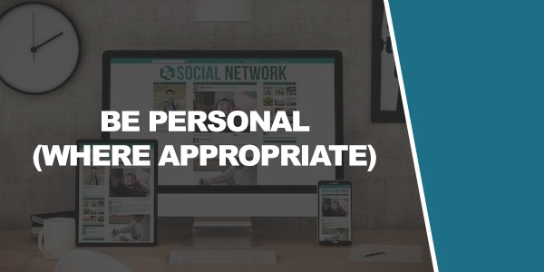
Be Personal (Where Appropriate)

Often, businesses will use their social media accounts in a very detached and ‘corporate manner’. We’ve seen this with the very bland and official sounding promotional posts that we discussed earlier in this book.
The unfortunate part of this is that often the companies are very well intentioned. Often, the aim behind this is to create posts that will sound official and ‘professional’ and they thus hope that they will be able to gain more followers as a result.
But the web is forcing business to adapt and today customers often don’t want to buy from businesses that attempt to be detached or corporate.
Instead, they want companies that are exciting, youthful and personable.
And this is why more and more successful businesses online use what is called a ‘personal brand’. A personal brand is essentially a brand that uses your name instead of a generic company name and that incorporates your own personality and lifestyle into the promotional and marketing material.
This works particularly well when you are selling some kind of lifestyle, such as fitness or money making. Then, you can address your followers

using your own name, talk personally about how the product or information you’re selling worked for you and meanwhile try to develop what will feel like a real relationship with your followers. Let them share insights into your daily routine, see your lifestyle and generally enjoy being a part of your lifestyle every day.
This is a great way to use social media and what works especially well about it is that your audience can feel as though they almost know you. This in turn will make them considerably more trusting and thereby more inclined to be interested in buying from you etc.
But the key with personal brands is to make sure that your niche and your industry is suited to this type of promotion. For example, if your business is a B2B company, such as an accounting or consulting firm, then having a chatty ‘personal brand’ where you post pictures of your morning cereal or amusing thoughts might not be terribly appropriate.
However, for marketing to individuals and where building trust and familiarity can be an asset, this becomes a much better strategy and it’s very engaging while creating lots of opportunities for new posts.

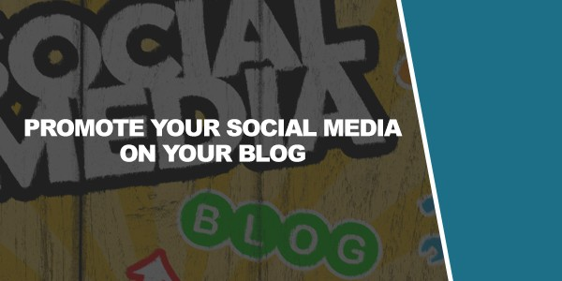
Promote Your Social Media on Your Blog

Here’s a very simple principle that nevertheless gets overlooked a lot – which is to promote your social media channels on your blogs. Too often, companies and marketers will think of their social media as a tool to promote their website only, not realizing that this actually can work both ways.
In fact though, promoting your social media on your blog is a great way to promote both aspects of your business and to capture your visitors and turn them into warm leads.
This way, if someone should land on your website for the first time and find they enjoy your brand, then they might decide that they want to follow you and learn more. Once they’ve seen your logo right there on the page, seen some of your posts etc., they will have a much better idea of what you’re all about.
Then, if you have social media buttons right there – and you draw attention to them in your content – your new visitors can opt to follow you and stay updated (and this is easier than capturing email addresses).

Now you have direct contact with your audience and you can promote to them in future. That means they’re more likely to come back to your blog and it means that they’re more likely to share your blog posts with their connections on social media. This then creates something of a ‘virtuous cycle’ (the opposite of a vicious cycle!). Everything you do to promote your social media will now better promote your blog and everything that promotes your blog will lead to more traffic on your social media! This also establishes that clear link and ensures that it’s very obvious that you are one brand that has multiple social media channels. The whole things becomes a self-sustaining loop!
Of course this also goes for social sharing buttons – make sure it’s easy for people visiting your site to share your content on their social media pages by liking it or Tweeting it. This is a great way to get more exposure for your blog posts.

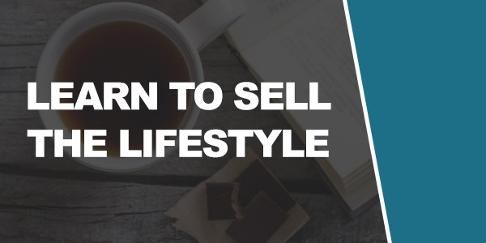
Learn to Sell the Lifestyle

Ever heard of Instagram stunting? To the uninitiated it might seem really rather strange and that’s because… it is! The basic idea here is that people on Instagram pose as being rich. To do this, they will post pictures of themselves doing things like eating dinner in front of large piles of money, or holding a steering wheel with their hand in just the right angle to show off their Rolexes. You know, just like real rich people would (hmm…).
Of course the reality is that these people very often actually aren’t rich but their channel is all about promoting the ‘lifestyle’. Sound ostentatious and crass? Be that as it may, it is something that certain people enjoy and as such, these accounts have thousands of followers.
Then there are the women who make most of their money from fashion sponsors. These Instagram stars will post heavily Photoshopped images of themselves looking stunning and immaculate, with impossible proportions while laughing at the sunset. It’s again all very staged but it sells a lifestyle and allows their followers to live vicariously. At the same time, this also promotes the products they’re wearing and therefore it’s a perfect match between the product and the account.

Now, I’m not saying you should do either of these things. But understanding that key element of promoting a lifestyle with your posts really can help – especially for those personal brands. The key is to make everything look desirable and just perfectly poised, again it is to understand the wants of your audience (and persona) and it is to try and tell a story with your images. Try to inspire and create photos that are artistic and polished and you’ll find people can’t get enough of it.
There are legions of photos of people’s work setups in fact!

Respond and Engage

Just as you need to focus on the social element by encouraging people to feel like a part of a movement, it’s also important to emphasize two-way communication by actually talking with your visitors and engaging with them.
Don’t underestimate the value of a single fan. Because that one fan could end up being the person who promotes your post on a forum somewhere that leads to your big break. Answer questions, respond to complements and let your audience feel like they can talk directly to you. This will once again also inspire trust and give them the confidence to feel that they can buy from you and not worrying about their money disappearing and the product never appearing!
It can take a while to answer everything and once your influx of content gets too big you’ll of course be unable to answer everything. But in the meantime, responding regularly is a great way to get people behind you!
Oh and don’t think that you always necessarily have to wait for them to make the ‘first move’ either. There’s nothing wrong with occasionally

reaching out to someone by liking one of their posts, or by commenting on something they’ve done. This is a great feeling for someone who is a fan and can create a feeling of gratitude.
And it might interest you at this point to know that whenever we feel in debt, that feeling doesn’t go away unless we give something back of greater value. So if you like someone’s post, it’s actually not out of the question that they might feel moved to repay your kindness by buying your product!
You can also invite communication by asking questions – and remember that this is actually a whole secondary usage for your social media too: you can use your social media as a way to survey your audience and to get their advice and opinions on matters. Trying to come up with a good name for your new product? Why not ask your audience? Want to know why no one is buying your ebook… why not ask? You can even simply as: ‘what would you like to see from us next’? This is something of a fool-proof strategy, considering that you’re asking the very audience that you intend on selling to. If they’re telling you they would buy a book on a given subject, then why wouldn’t you write it?
And this goes even further because now they will feel like they had a hand in its creation – and that sense of ownership makes them even more likely to want to buy!

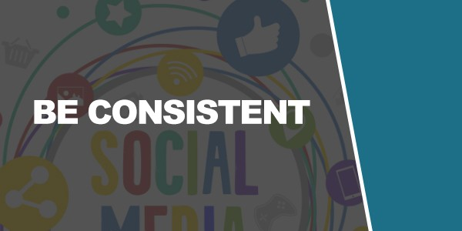
Be Consistent

So at this point in the book we have learned an awful lot. You now know how to write great content, how to keep people coming back to your site and how to engage your audience so that they feel like part of an exciting VIP community. This is all going to put you on track to a fantastic and highly successful social media account that is only likely to grow with time!
But that is the operative word here: time.
In order for your account to be successful, you need to keep doing the right thing over and over again.
What’s more, is that once you’ve established a pattern, you need to stick with it.
For starters, posting regularly and engaging regularly etc. is the only way to slowly grow your followers. This can be tiring and disheartening at first as it will always start with a very slow trickle of new fans. Over time though, you will find you’re able to build momentum and eventually it will start to see exponential growth.

The key is to stick with it until then, and while you do, to make sure that you’re following the same blueprint. One important reason for this is that any big pause in content, or any sudden change in what you post, can very quickly lead to a loss of fans.
This is a danger when it comes to creating a personal brand. If you build yourself a personal brand that is tied to your business, then it can end up creating a scenario where half of your posts are about your business or your chosen niche and half of them are about your cereal, or getting stuck in traffic. Maybe something you’re enjoying on TV.
And if someone followed you because they wanted to learn more about their favorite subject and they keep getting updated with inane posts about your day, then eventually they might end up becoming bored with your random content and thus stop following you.
This is of course the situation you want to avoid, which is why it’s so important that you set a very clear tone and subject matter for your content before you begin. If you’re going to be posting on your lifestyle and tying that to your niche, then keep it loosely related to selling the dream and make sure that your audience knows what to expect. That way, they will get what they came for and that will ensure that they feel as though they’re getting the value they were promised!

For More Difficult Niches

We’ve talked a lot about how to create value and offer something useful when you are selling a fitness program or make money online program. But in reality, this is a relatively easy ‘sell’ compared to many of the other things you can find yourself doing as a digital marketer or a business trying to use social media.
Because if you run a business that’s about car breakdowns, about accounting, or about life insurance… then how can you create a consistent topic that people would actually want to subscribe to?

This is the difference between a product that people want versus one that people need. How can you ‘sell the dream’ of life insurance or PPI?
The answer is to go a little off topic. Remember what we said earlier about your social media really being a standalone product or service in its own right? Remember that we mentioned you needed to make something that people would be sad to see gone?
You simply have to take this idea one step further when you’re selling a product that people will struggle to get excited about. Find a topic or a service that is tangential but indirectly relevant to what you’re selling and then find a way to make that desirable and interesting.
So for example, if you are selling life insurance, then you might create a social media channel that promotes family life. This is directly on the subject of life insurance but now it’s something that someone might actually watch. It’s something that provides value, inspiration and entertainment.
And it has the same ‘Why’. See how it all ties together? You see why you need to think about your brand before you head out with your campaign? Life Insurance is all about protecting your family and keeping them happy when you’re gone. A channel about fun things to do with your family is likewise going to be all about making the most of time with your family and keeping them happy.
Furthermore, a social media account that promotes family life will appeal to the exact same demographic. People looking for family activities are the same people who need life insurance so that their family members will be protected when they’re gone.
This is the perfect opportunity to create something on Pinterest for example, or on Instagram. Or you could create a Facebook page and post ideas and tips from around the web.
If your business is in auto insurance, then you could post photos of nice looking cars. If your business is in suits, then you could create a channel all about looking professional and progressing at work.

I can’t run through every example here but hopefully you have the gist. Get creative, think outside the box and see what you can come up with!

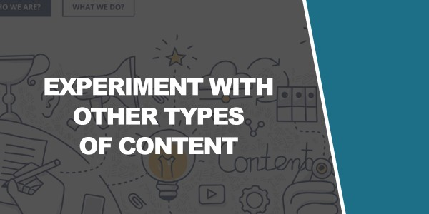
Experiment With Other Types of Content

On Facebook and Twitter, the main ways you are likely to promote your brand are by posting comments about your niche or links to content on your site or other external sites. This will provide entertainment and value and help you to build up an audience.
On Instagram and Pinterest of course, you will be posting images largely. And on YouTube, you’ll be posting videos.
But keep in mind that there are plenty more types of content you can post as well!
One great example of this is to post quizzes. Quizzes are highly popular because they allow people to learn something about themselves and then share that fun with their friends.
Games are great meanwhile because they offer clear value and keep people engaged on your page (very good for SEO).
Infographics are commonly very popular around the web too as a way to convey a lot of information.

Online calculators are an option – even something more creative like a webcomic or desktop background!
In other words, the aim here is to stand out by offering something different and interesting that no one else is offering and that ideally offers a different kind of value. By giving people media of some sort that’s free, you’ll find that you very quickly garner more attention and this is a great way to get your brand noticed and to get more clicks.
In general, being different is a very good piece of advice!

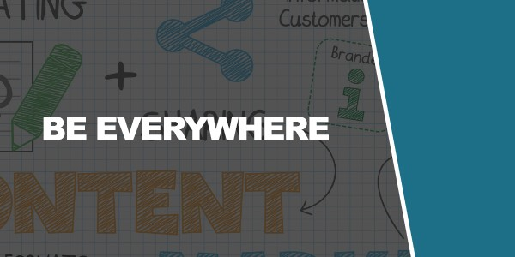
Be Everywhere

This ties in neatly with the advice that you should try to be everywhere.
In other words, don’t focus all your attention on Facebook or on Twitter – be on every type of social media under the sun and use their different benefits and weaknesses to offer something really unique and interesting that others are not offering.
Meanwhile, being on multiple forms of social media makes your brand appear more professional and capable, as it shows that you’ve been able to invest into lots of different aspects of the web and that you’ve thought of every angle.
Finally, being on multiple different channels as far as social media is concerned allows you to corner each different part of the market.
On Facebook for example, you’ll be able to benefit from gaining access to the largest possible audience and giving yourself plenty of options for communicating directly with your audience. On another social media channel however – such as Periscope – you’ll find you have a much smaller audience but that this also means much less competition.

Being on a small social network then allows you to build a following in a place where there isn’t much competition and then to bring that following over to the larger networks in order to get a leg up that can help you to gain some real momentum and start to tap into that even bigger audience.
Finally, being on multiple channels just gives your fans lots of ways to interact with you. That means they can enjoy your content in different formats and it means that they can choose the method of following you that best suits their particular preferences. Perhaps they like images and would rather follow you on Instagram? Or maybe they’re someone who likes to read in-depth posts, in which case they might benefit from following you on Facebook where they can see all your posts. By being on both, you can ensure that you won’t miss out on anyone!

Case Study: Arnie on Snapchat

Snapchat is definitely one of the lesser regarding social media networks among internet marketers. That’s because it has a much smaller following still and no real ‘home feed’ or place where people can reshare content or find new creators.
But what Snapchat does allow you to do is to create content that really feels immediately and like you’re bringing people along with you. It’s different, it’s interesting and the new filters make it really fun.
This is why Arnie has managed to have a massive amount of success on Snapchat by sharing his posts on other social media channels (like Facebook) and then encouraging his fans there to follow him on Snapchat if they want to see more of those kinds of antics.
Best of all is that Snapchat notifications appear right in the toolbar and thus have some of the best open rates in the industry. So Arnie can take his big audience from Facebook and then create a more personal relationship with his biggest fans on Snapchat!

And his account has been so successful that he has actually arguably helped to boost Snapchat itself – so much so that there was recently a filter based on him released on his birthday!
The funny thing is, that you never know which of your social accounts will be the one to take off. But the more you have, the more opportunities you give yourself.

Take Advantage of New Technologies

So Snapchat is an example of a relatively new social media channel but it’s not the ‘big thing’ right now. Instead, that big thing is probably live video streaming which involves filming videos and broadcasting them live through apps like Periscope and Meerkat. Recently, Facebook got on board and now you can stream live video to your Facebook fans too.
The great thing about this is that it lets you communicate directly with your audience. If you post a video on any of these channels, then your viewers will be able to post comments on what you’ve written and that way, you can then actually answer them live, giving them the opportunity to ask you about your products or to just chat with you and ask questions about your niche.
They will thus feel far more engaged with your content and far more inclined to stick around as long-time followers because they’ve actually had a chance to feel as though they’ve chatted with you!
But what’s more, is that these channels are currently very quiet despite being highly exciting for early adopters. So there are a lot of viewers

heading here regularly but there’s not that much content ready for them yet. Right now, if you post a live video, then you can get followers nearly every time you do on something like Facebook!
Plus, you can experiment with new ways to create content and use the channel. Do you bring your audience on your hike up a mountain? Do you share the event you’re at or the concert? Or do you use it for a vlogging Q&A over your morning cup of coffee? There are tons of options and the great thing about these platforms being new is that you can innovate and be the first.
There are more new social networks cropping up all the time and it’s a wise idea to get involved early whenever you can. If you can establish a following on a new social network only for it to later take off, then you will have a foothold right when all the new users start coming in!

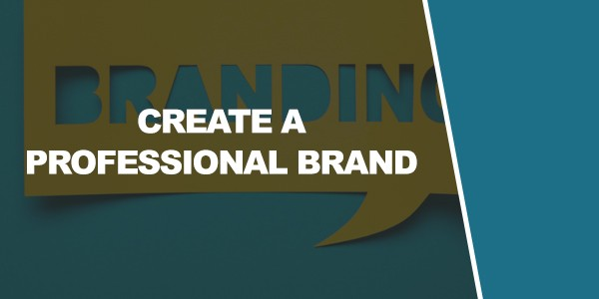
Create a Professional Brand

None of this cross promotion will work though unless you have a consistent and professional looking brand.
We already discussed what a brand really ‘means’ in terms of creating something that has a reason ‘why’ behind it and that people can get excited about. But now we’re talking about the more basic aspects of your brand – the name and the logo for instance. Perhaps even a jingle or a byline.
Getting this right is crucial because it will make your brand look that much more professional and it will help people to more easily connect the dots and see that your many social media accounts are all from the very same company/person.
In an ideal world, your account on Twitter will be the same as your account on Instagram, which will be the same as Facebook. That means the same username, same logo and same ethos. Doing this will create consistency and greatly strengthen your brand consistency.
But it also needs to look good. So how do you make a logo look good?

Logo Design Tips

What makes a good logo design?
Many things – but the first and most important thing to consider here is that you need to either use the best software or outsource your logo design to a good company. Preferably the latter. They should then provide you with a vector file, such as an AI file and this will allow you to resize your logo as much as you want with no loss of quality. It should also make editing much easier. This is very important because it will allow you to keep the exact same logo and keep it looking crisp and HD. You need to stay absolutely consistent here with the exact same color codes and more. If don’t know what a vector file is, then you should hire someone: it’s more than worth the investment if it means your brand looks more professional.
But as well as maintaining production values what’s also very important is to make sure your logo has the best design in the first place. What makes a good logo? Here are some points:
- Keep it simple – The best logo is easy to identify and replicate. Nike gets free promotion every time a kid drawers its tick in their homework diary!

- And versatile – Simple is also good because it is versatile. Remember that your logo is going to be used everywhere from your website, to your products themselves, to your ebook and more. When you create your logo then, you need to ensure it will work at any size and on a variety of different colored backgrounds. Try to avoid anything too detailed then, or anything that couldn’t be identified from a silhouette if necessary!

- Communicate – Ideally, your company name and your logo should communicate a little about what your business is about and what the tone and style of your business is. Let’s take a look at the logo of ‘The Art of Manliness’. That name alone perfectly communicates what the site is about but when you combine that with the logo which has an old fashioned typeface and a moustache, plus the image of the old-

fashioned boxer – you quickly realize that this is a somewhat vintage and moderately tongue-in-cheek tone. This is ideal because a lot of people will know right away whether they’re likely to enjoy your brand and might follow you right there and then with no further information necessary!

- Be unique – Do whatever you can to avoid clichés like lightbulbs, ticks and globes. They’re everywhere and if you employ these, you’ll risk making your brand just look a little unimaginative!

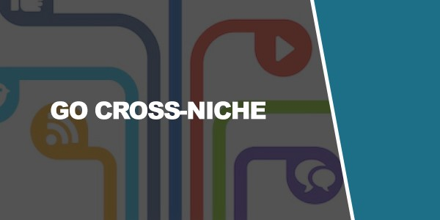
Go Cross-Niche

So you’re getting yourself onto every single social media planet under the sun, great! Next, you need to think about getting yourself into multiple communities so that you can be seen by as many people as possible on those social media channels.
For example, if you have a blog about building muscle then you don’t only need to post in muscle building communities. You can just as well post in style communities and martial arts communities – both these groups might be interested in the subject matter and especially if you find a way to make it applicable. An article like ‘How to Build Muscle for Grappling’ is a unique topic and a great way to bring a whole new audience to your site!
This is another reason that The Art of Manliness is such a good brand – it combines lots of niches under one heading, making something that has a clear and defined purpose while still appealing to a lot of people!

Don’t Try to Cater to Everyone

BUT with that said, you also shouldn’t try to appeal to everyone. The old saying goes that if you try and please everyone, you’ll end up pleasing no- one. And that is definitely true in this scenario.
We’ve talked at length about the importance of having a very clear and defined brand with a clear purpose. Know what you’re about and know who you cater to. And don’t water down that message to appeal to everyone.
Why? Because that’s how you end up back with articles like ‘7 Ab Exercises You Can Do At Home!’. It’s bland, it doesn’t stand out and you’re now competing with the entire niche.
A good example here is Brain Pickings. Brain Pickings is a blog run by Maria Popova that specializes in truly in-depth and highbrow content about the brain, literature, philosophy, politics, art and more.
An example of a post on the site is:
“Oliver Sacks on Death, Destiny and the Redemptive Radiance of a Life Fully Lived”.

Now that’s definitely not a post that has ‘mass appeal’! But that’s actually perfect because it’s the very reason that the site has done so well. For the right kind of reader, this is a very unique site that will offer just the kind of content they like – and that they can’t find anywhere else. It instantly stands out, it’s immediately apparent that it is different and it’s overall a very strong brand.
Another thing to consider here is that you don’t want to try and get everyone to your website and blog anyway, meaning you don’t want to get everyone to sign up for your social media. For most people reading this, a social media account will be used to sell a product. And as you likely know, that means you want targeted leads. Getting the wrong kind of person to your site means you probably won’t sell products to them, so this will have been a waste of everyone’s time. If you’re building a community, then they likely won’t have as much to contribute as the people who are real fans of the kind of content you are putting out.
So instead, focus on creating something really unique and focussing on that specific persona. Don’t be afraid to turn some people off from your blog, as they likely weren’t the right fit anyway!

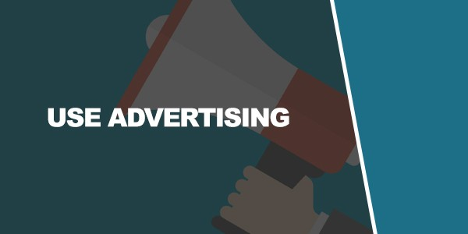
Use Advertising

With all these techniques, you’ll be able to start generating something of a following. But you can also help this along with the right advertising campaign.
And on social media, this is often going to mean paying for PPC (Pay Per Click) or sponsored posts. Either way, you can get more people to see your content but you’ll be paying in order to do this. Thus things get a little more complicated.
Is it worthwhile? Potentially yes but only if your business is prepared.
Spending money on advertisement should always be an investment which means you should always make more money as a result of that initial spend. To calculate whether that is in fact the case though, you need to be able to work out what the ‘Customer Lifetime Value’ is for your brand.
How many of your leads become customers? How much money do you make from each sale? How many of your customers buy more than one item? And with all that in mind, how much is each customer worth to you?

Knowing this, you can then decide how much you are willing to pay per click for someone to see your content.
But the great thing about social media advertising and PPC is that it allows you to see metrics, to more precisely target your adverts and even to set up ‘CPA’ (Cost Per Action), in which case you will only have to pay if – for instance – someone actually ‘likes’ your Facebook page. This way, you are getting a lot more for your money and can potentially increase your profits. It takes a lot of tweaking and work but if you get it right, this can be a very good investment and way to grow your following.

Work With Partners and Influencers

Another way to get a leg up in the world of social media marketing is to work with partners and influencer marketers.
This is something you’ll often see on YouTube. Here, one vlogger might feature a guest on their channel, who will be a presenter from a similar channel. They’ll then return the favor and this way, audiences of both channels get a taste of what the other creator is like and some may start following them.
By sharing their followers this way, two content creators can help each other out and grow their channel. And failing that, you can always just pay for an influencer – someone with a massive following – to give you a shout- out.
Either way, this can be a great way to get a big sudden boost to your followers and a spike in traffic. But the key to success is not to be too ambitious to start with and to instead build your way up gradually. Don’t immediately go after the biggest name in your niche – they get a lot of offers and probably don’t have the time to answer you.

Instead, start with someone at a similar level to you who has the same amount to gain as you do. You can then help each other out and the boost in followers you both receive will often then be enough to mean you can approach an even bigger name next time!
Inherent in this is not to see other people in your niche as a threat but rather as colleagues. Apart from anything else, demonstrating association with them will help to give your channel more credibility and that in turn will mean others take you more seriously, more quickly.

Use Contests and Other Events

Another promotional method is to run some kind of contest or event.
This can, for example, mean that you promise to do something if enough people Like your page (a great way to encourage more people to sign up). You could alternatively offer free promotion to people who use #yourbrand and take photos using your products on Instagram. Or you could use promotions like events (actual meetups!) or opportunities for people to name products or win prizes.
In all of these cases, you are giving people more reason to interact with your brand, to spread the word, to provide you with free marketing and promotion and to engage with you. All these things will help to strengthen you as a brand and at the same draw more attention to your channel and it’s a great way to get the occasional extra boost.
Other than ongoing schemes though (such as hashtags), try not to over- egg this one. Otherwise, people can quickly get fed up of a scenario where you aren’t providing value anymore but are instead just running promotion after promotion.

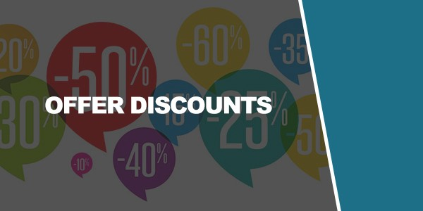
Offer Discounts

While we said that you shouldn’t focus too much on promoting your own products and services, one way that you can promote yourself and get away with it is by offering discounts and money off. Surveys show that this is something that most social media users actually appreciate (rather than seeing as a nuisance) and as such, you can usually get away with it!
Offering discounts really is a way of providing value, because they are getting money off of something. That means they have saved money by following you and that in turn means they received value!
Another great thing about offering promotions is that Facebook’s CPA (Cost Per Action) ads actually let you use ‘redeeming a voucher’ as an action. So if you run a promotion and pay for advertising on Facebook, you can set it up so that it only costs you money when someone actually bites and pays for your product. This means you can precisely calculate your profits and feed money into your advertising to increase turnover and revenue!
When you try and attract more people to your social media account, you should make it clear that you will be providing offers. This way, people

won’t be annoyed or frustrated when you occasionally mention that there’s a 10% money off deal and better yet, it means that everyone following you will be potentially open to your offers. That’s a very targeted audience right there!
Oh and another thing: remember to use the VIP approach when mentioning your offers. Remember, these are exclusive and exciting offers that they can’t get anywhere else. These are completely unique and they are being offered them because they are part of your movement. This can make your audience feel special again, which will increase their likelihood of wanting to take advantage of their good fortune by making an order!

Understand the Psychology of Sharing

Something that’s useful to cultivate for your social media is to better understand the psychology of sharing. Why do people share? What makes a video go viral?
The first thing to recognize here is that no-one can set out with the intention of creating a viral video and be guaranteed success. Some things increase your likelihood of a hit (such as keeping the video short-ish and making it funny and/or shocking) but there’s a lot of luck involved and a certain ‘X Factor’ that can’t be quantified.
But by understanding why people share, you can greatly improve your odds.
And this basically comes down to remembering the purpose of social media and why people sign up in the first place. First and foremost, people sign up to social media as a form of communication. This is a means of staying in touch with friends and expressing yourself and that means you are very likely to share content if it helps you to do either of those things.

That expression is one VERY big part of this. When we socialize in the real world, a lot of this involves thinking about the image we want to give off and how we want to project ourselves. That’s why we wear certain clothes, buy bling and workout. It’s also why we’re so keen to tell people all about ourselves!
That narcissism is even more apparent on social media where most of what we post is about ourselves!
So if you create an online quiz, then you can understand why it is likely to be very successful with people sharing their results!
Moreover though, if you create a blog post with a very clear identity that says something about your readers – then people will share that as a way to show that they identify with what you’ve said and this in turn allows them to express themselves in that way.
Make a blog post about vegetarianism and lots of vegetarians will share that content to show that that’s who they are and that that’s a part of them. Post about why it’s finally time that you got in the gym and people who feel the same will want to share it (remember how we said that people feel like sharing their goals is the first step in achieving them?). Post about the amusing aspects of working from home and if your readers associate with you, they’ll share it!
The other reason someone might share this content is to show they’re thinking of someone and to show that they understand them. Again, this is why it’s such a good idea to post with a very specific target audience in mind and not to try to cater to everyone!
If you write a post about the health benefits of knitting, then you’ll find that people share it with their friends if they know that their friends like to knit. Try to trigger the ‘Ooh, John will like that!’ effect.

Make Great Quality Posts

All this only works though if you make your posts excellent quality.
Your post title can be as on-point as you like but that will only take you so far if your content is poor. If your friend tagged you in a post and you read it only to find that it was poorly spelled and very dull, you’d likely just be annoyed at them!
So make sure that your content is excellent quality and that means not only in terms of the subject matter and offering value but also in terms of the way it is written and even the way it is presented. Great content is long, in- depth and filled with useful takeaways. It uses well-written, error-free copy and it is made to be engaging and instantly gripping.
If you don’t have the writing skills to deliver on that, then you either need to cultivate them, or you need to hire someone who can do it for you.

Learn to Take Amazing Photos

Likewise, for posting content to sites like Instagram, it can really pay to learn how to create great quality photos. That means you should be able to create photos that tell a story, sell a dream and make people instantly want to click on them and open them from the thumbnail alone.
A good starting tip is of course to invest in a better camera. This is going to instantly give you much better looking shots and also create more options as you can take photos in lower light, or adjust things such as the focus so that you can blur out the background. All these things will help you to build a bigger audience while also creating a more professional look and feel for your social media accounts that will bring in more followers.
Some more tips:
  - Think about lighting – Rembrandt lighting is best which means that you’re lighting your subjects from the side rather than head on which creates ‘flat lighting’

  - Think about composition – Your images should have a sense of depth, which can be achieved by having elements in the foreground,

middle ground and background. Another tip is to have something that leads from the foreground to the background, such as a pavement or a road.

- Tell a story – Don’t always make your subject obvious. Instead of taking a photo of a party, try photographing the aftermath of the party, or an empty glass with confetti around it. This tells the audience more and creates a much more artistic shot.

Automate

All this can be a lot of work and especially when you consider that you’re trying to get your content onto all those different social media accounts and keep up regular posting. It’s for these reasons that it can be a good idea to automate some of the process by using tools like IFTTT (If This Then That at IFTTT.com) or Hootsuite (Hootsuite.com).

These allow you to schedule posts, or to post the same message to multiple different accounts at once rather than just the one.

That means that you’ll never go a long period with no new posts on your sites - but it’s not an excuse not to ever engage with your visitors manually or to create your own content from scratch.

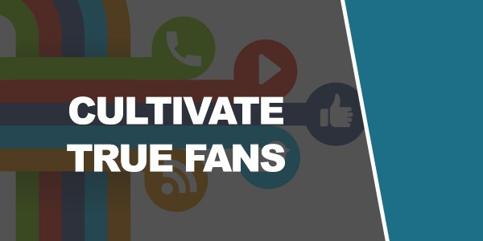
Cultivate True Fans

All of this should be practiced with a single end in mind: to create not just social media followers but true fans. Your aim is to make people passionate about your brand. Don’t think about quantity, think about quality.

In turn, you’ll get a higher quality of fan – people who appreciate the work you’re putting in, your original and unique content and your clear vision.

And as the book of the same name says, all you really need is 1,000 true
fans and you’ll find that your brand grows exponentially from there!

Conclusion

So there you have it: 27 social media principles that can transform your approach to growing on social media and help you to gain a loyal, passionate following that will lead to exponential growth and eventually to sales.
It sounds like a lot but actually, there are a lot of common threads between these tips. The key is to have a brand with a vision and a purpose. It’s to be passionate about what you do and to have a brand that people can really get behind. From there, you’ll then express that value proposition and that vision through high quality content – rather than just posting promotions and advertising. Engage with your audience, get them involved with your movement and be consistent.
If you do all this and if you work to get your brand onto every social media channel you can, then it is only a matter of time until you begin to grow.
Oh and that’s one more reason to make sure that you really enjoy and believe in what you’re doing. If you don’t, then it’s very easy to become

disheartened when you don’t see results overnight. Do it for the love and your following will come.

IMPORTANT: To help you further take action, print out a copy of the Checklist and Mindmap I provided. You’ll also find a Resource Cheat Sheet with valuable sites, posts and articles that I recommend you go through.

